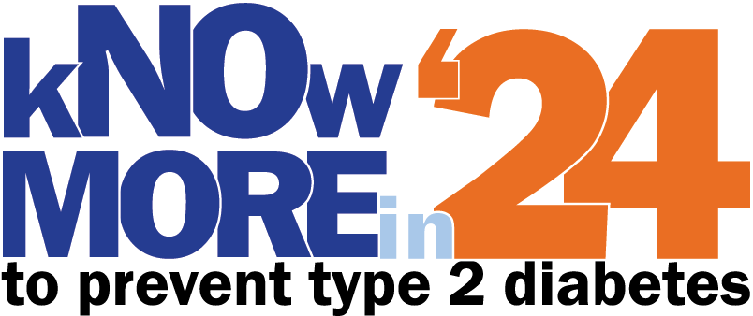

Dear (Recipient Name),

I hope this email finds you well. I am reaching out to you on behalf of the Kentucky Diabetes Network (KDN). As an organization committed to health advocacy since 2002, KDN has been at the forefront of championing the well-being of Kentuckians at risk for and living with diabetes.

Today, I’m excited to unveil to you, the "kNOw More in '24" campaign, and I am reaching out to invite you to learn more and join us in shaping a healthier community.

Diabetes Challenge in Kentucky:
It is concerning that 13.8% of Kentucky adults currently have diabetes, with an additional 12% estimated to have prediabetes. This health issue impacts families across generations and underscores the urgent need for collaborative efforts to address and mitigate its impact.

Past Success: Prevent T2 in '22:
I am pleased to share the success of our previous campaign, "Prevent T2 in '22." In 2022, this initiative achieved remarkable outcomes by spotlighting behaviors and programs for preventive changes. The success of this campaign even led neighboring states to reach out to us, expressing their interest in joining our efforts.

Continuing Momentum: kNOw More in '24:
Building on the momentum of our past success, KDN is proud to introduce the "kNOw More in '24" campaign. This initiative aims to increase awareness around behaviors that prevent development of diabetes, specifically targeting young adults, teenagers, and children to ensure a healthier future for our community.

Partner opportunity suggestions:

- Set up a booth at a Farmers Market:
  - Create an engaging booth with information on health and wellness.
  - Distribute pamphlets, brochures, or freebies related to healthy living.

- Offer Garden demonstrations:
  - Organize workshops on gardening techniques, emphasizing the health benefits of growing your own food.

- Offer lunch and learns at local organizations:
  - Collaborate with local businesses or organizations to provide informative sessions during lunch hours.
  - Cover topics included in the campaign.

- Post pictures of activity with #kNOwMore on social media:
  - Create a social media campaign to share updates, tips, and success stories.
  - Encourage the community to use the hashtag #kNOwMore to spread awareness.

- Start a walking club or plan an event:
  - Organize regular or one-time group walks for community members.
  - Include themed walks like "Walk the Dog" or "Walk with the Doc."

- Share annual activity events you have in place:
  - Highlight and promote any annual events related to healthy initiatives.
  - Encourage community participation and engagement in the campaign.

- Faith community partnerships – tables at events/church:
  - Partner with local faith communities to set up informational tables at their events.
  - Engage with community members and share resources.

- Cooking demos:
  - Conduct cooking demonstrations focusing on healthy and affordable recipes.
  - Provide recipe cards or cooking tips for attendees.

- Post the doIhaveprediabetes.org screening item
  - Promote awareness about prediabetes by sharing screening information from doIhaveprediabetes.org.
  - Encourage community members to take the screening and seek further guidance if needed.

Thank you for considering our invitation. Together, let's make a difference in the lives of those at risk for or living with diabetes in Kentucky.

Warm regards,

Name
Title

Cc: kentuckydiabetes@Gmail.com

